



Create a database to manage student records stored in a table
LAB MANUAL

Disclaimer: The content is curated from online/offline resources and used for educational purpose only
Create a database to manage student records stored in a table

Objective:
The objective of this lab is to demonstrate how to create a database and table, insert and retrieve data, and perform data manipulation operations such as updating and deleting records using SQL commands.
Problem Statement:
Create a database and a Students table to store student records. The table will store information such as student_id, first_name, last_name, age, class_id, and total_score. We will use SQL queries to:
- Retrieve records and calculate the average total score of students.
- Update the total score of a specific student and increment the age of students in a specific class.
- Delete specific records based on conditions.

Requirements:
- A MySQL environment installed and running.
- SQL Workbench or a command-line tool for running SQL queries.
- Basic understanding of SQL commands such as CREATE, INSERT, SELECT, UPDATE, and DELETE.

Procedure:
Step 1: Start MySQL Server:
Open the command line or terminal.
On Windows: Use MySQL Workbench or run the mysql command.

- Create the Database and Table, and Insert Values

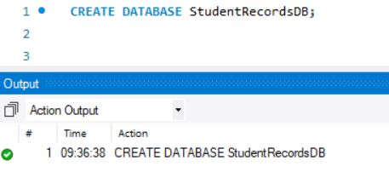

Now created a database named StudentRecordsDB to store all student-related information.

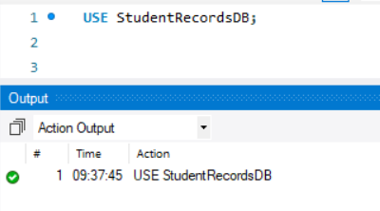

This statement switches the current session to the StudentRecordsDB database.

Create the Students Table:

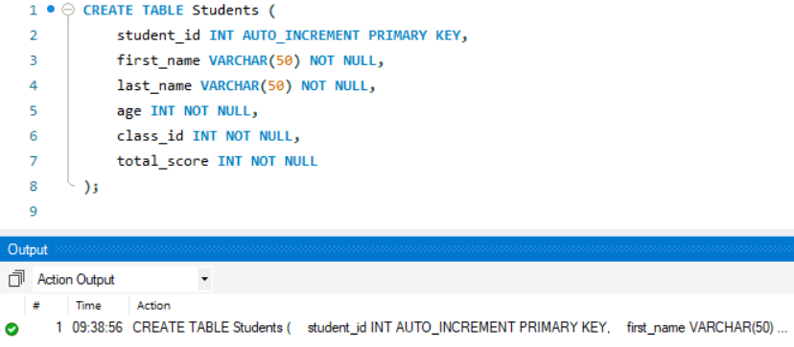

Creates a table named Students with fields for student details. The student_id column is set as the PRIMARY KEY with auto-increment functionality.

Insert Data
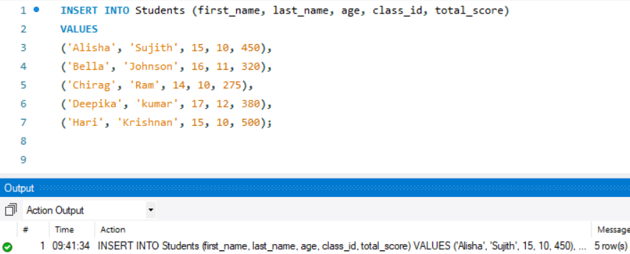

Inserts multiple records into the Students table with sample student data.

B) Write SQL Queries to Retrieve Data
Retrieve All Records from the Students Table:
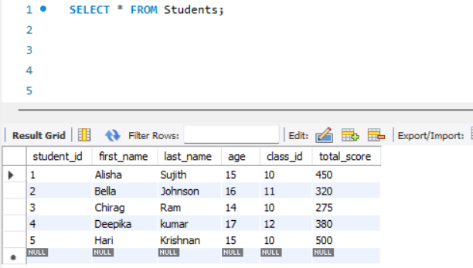
Fetches all columns and rows from the Students table.

Retrieve the Average Total Score of All Students:
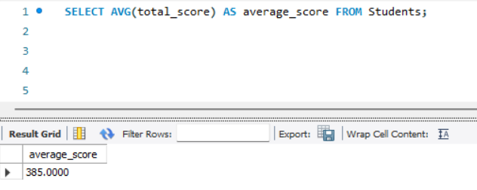

Calculates the average of the total_score column for all students in the table.

C) Write SQL Queries to Modify Data
Update the Total Score for student_id = 1 to 10:
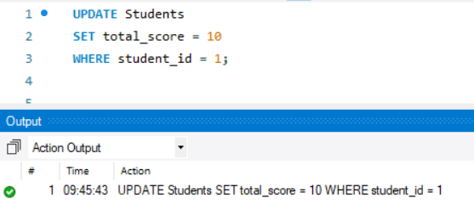
Updates the total_score field to 10 for the record with student_id = 1.

Increase the Age of All Students in Class 10 by 1 Year:

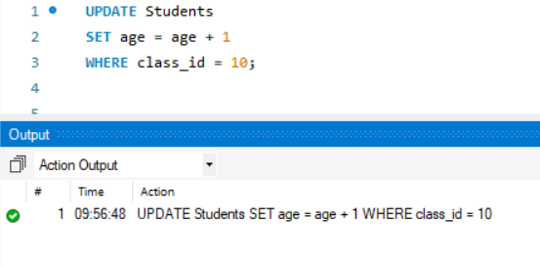
Increments the age column by 1 for all students in class_id = 10.

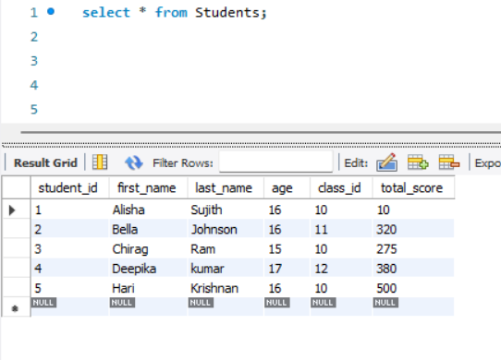
D) Write SQL Queries to Delete Data
Delete the Record of the Student with student_id = 3
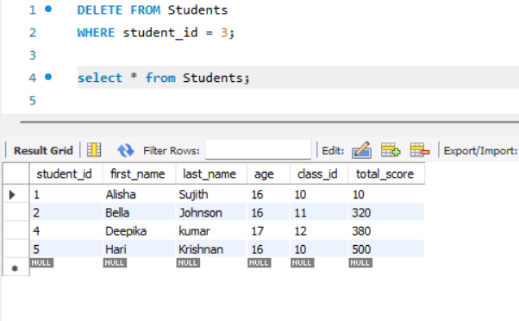

Removes the row where student_id equals 3 from the Students table.

Delete All Students Who Have a Total Score Less Than 300:
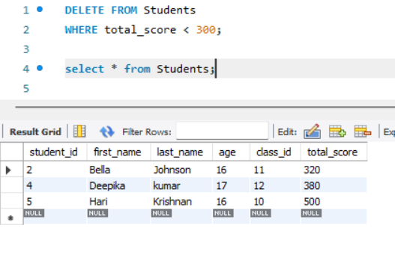
Deletes all records where the total_score is less than 300.

Output:
The queries was successfully executed

